**Linux Firewall Exploration SEED Lab**

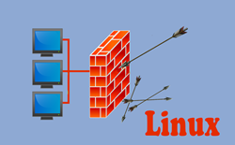

**Linux Firewall Exploration SEED Lab**

**Main Introduction:**

In this lab we will focus on packet filter. Packet filters inspect packets and decide whether to drop or forward.

We will understand how firewalls work. We will learn how to use SSH tunnels to bypass firewalls.

I will perform and use the following:

• Set Firewall (iptables) Rules

• Netfilter

• Loadable kernel module

• Bypassing firewalls using SSH tunnel

**Task 1: Using Firewall**

**Network physical topology:**

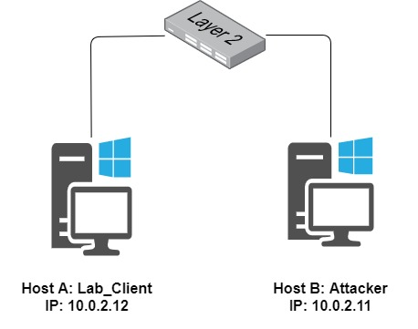

**Task Description:**

I will use iptables to prevent:

1. Host A (10.0.2.12) open telnet session to B (10.0.2.11)
2. Host A (10.0.2.11) open telnet session to B (10.0.2.12)
3. Host A (10.0.2.12) from surfing to a certain website

First, I will show successfully initiated telnet session between both.

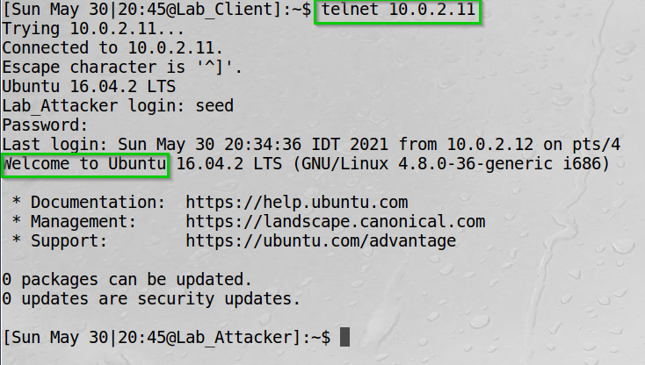Telnet to 10.0.2.11

We can see successful connection.

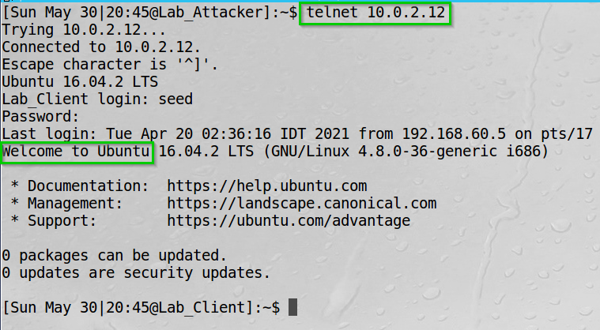Telnet to 10.0.2.12

We can see successful connection.

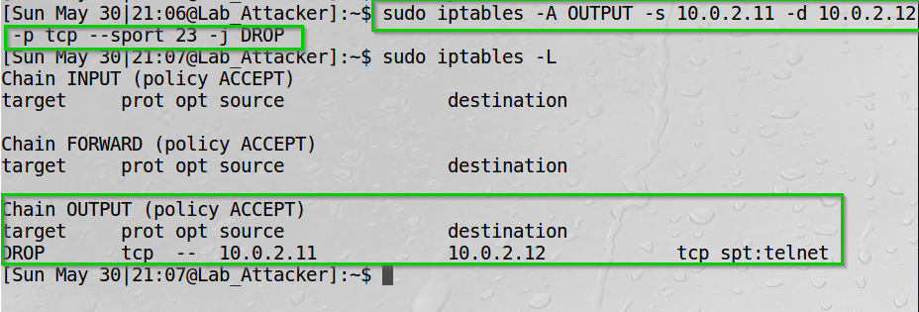The following rule block telnet from A to B (executed in B)

We can see the rule in the iptables.

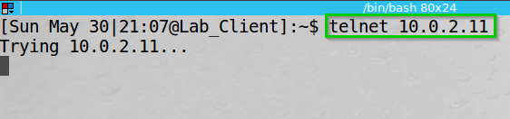Try initiating telnet from A to B.

We can see the connection could not be set.

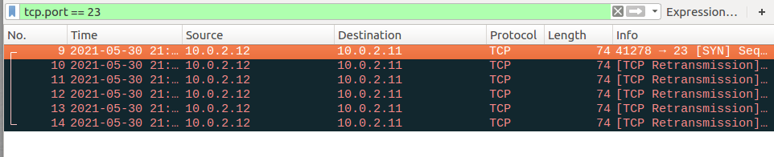Wireshark view on 10.0.2.11.

We can see 10.0.2.12 tries to connect to 10.0.2.11 but 10.0.2.11 does not reply since the packets are filtered.

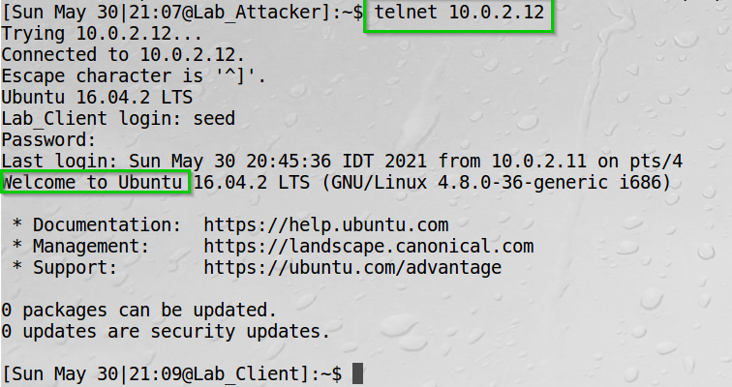I now show that B (10.0.2.11) can still initiate telnet to A (10.0.2.12).

We can see successful connection.

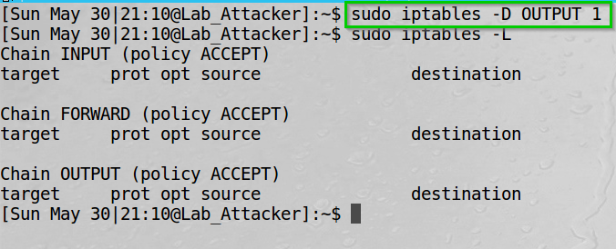  
Deleting the iptables rule.

We can see the rule is deleted from the iptables.

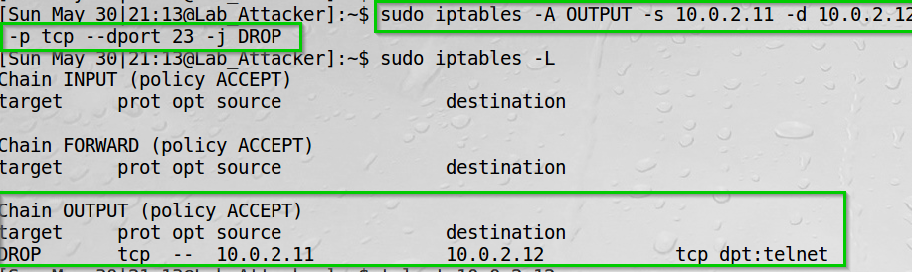The following rule block telnet from B to A (executed in B).

We can see the rule in the iptables.

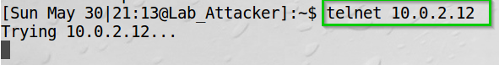We try initiating telnet from B to A.

We can see the connection could not be set.

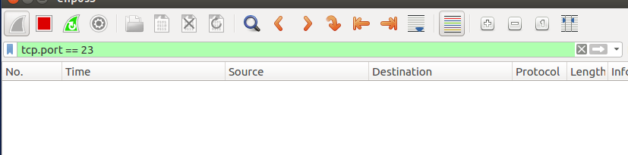Wireshark view on 10.0.2.11.

We can see there are no packets being sent on port 23.

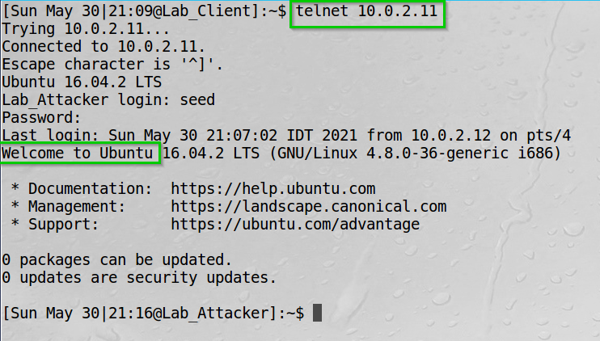Now I show that A (10.0.2.12) can still initiate telnet to B (10.0.2.11).

We can see successful connection.

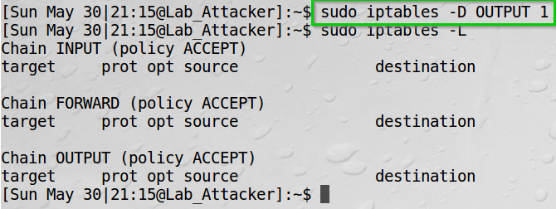  
Deleting the iptables rule.

We can see the rule is deleted from the iptables.

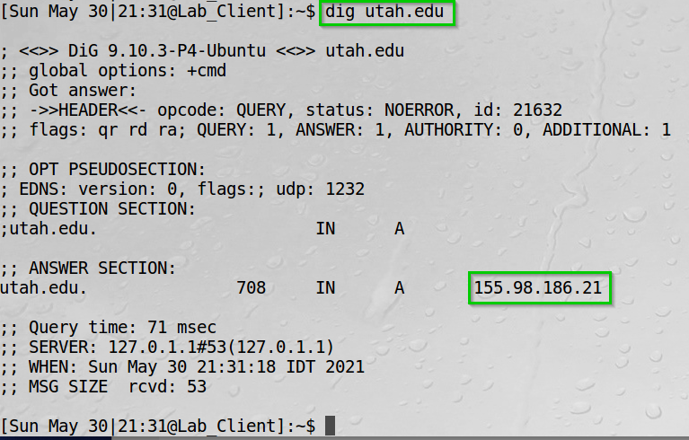Using dig command, I got Utah University website IP.

We can see the result 155.98.186.21.

The following rule block telnet from A (10.0.2.12) to Utah University website.

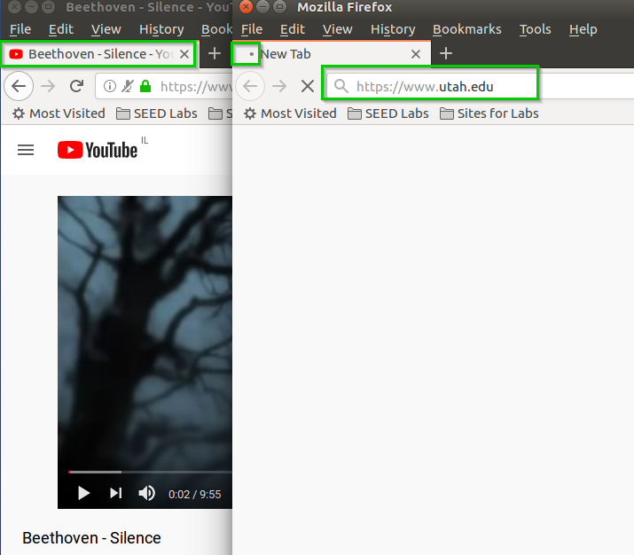I now tried browsing to Utah University website.

We can see unsuccessful attempt.   
YouTube is to show network connectivity.

Deleting the iptables rule.

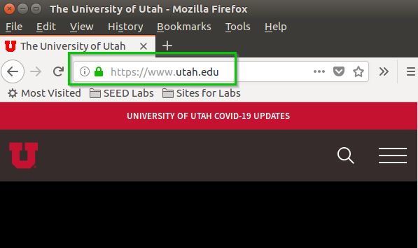We can browse now to Utah University website.

We can see a successful connection.

**Task 1 Summary**

* I have learned using iptables as our Firewall.
* I opened Telnet and SSH connection between A and B.  
  Then applied iptables rule to block the communication.
* I also blocked connection to Utah University website using iptables.
* I learned about iptables structure and rules.

**Task 2: Implementing a Simple Firewall**

**Task Description:**

In this task I will use LKM and Netfilter to implement packet filtering.  
We will filter:

* Outgoing SSH from 10.0.2.12 to 10.0.2.11
* Outgoing Telnet from 10.0.2.12 to 10.0.2.11
* Incoming SSH from 10.0.2.11 to 10.0.2.12
* Incoming Telnet from 10.0.2.11 to 10.0.2.12
* Outgoing Web communication with Utah University website.

Loadable Kernel Module are module we can inject directly to the OS kernel using Netfilter.  
Netfilter implements ‘hooks’ on the operating system – thus, capturing system calls before they move from the kernel to the operating system.  
Therefore giving us the first control over the packets filtered.

To achieve my goal, I wrote the following code:

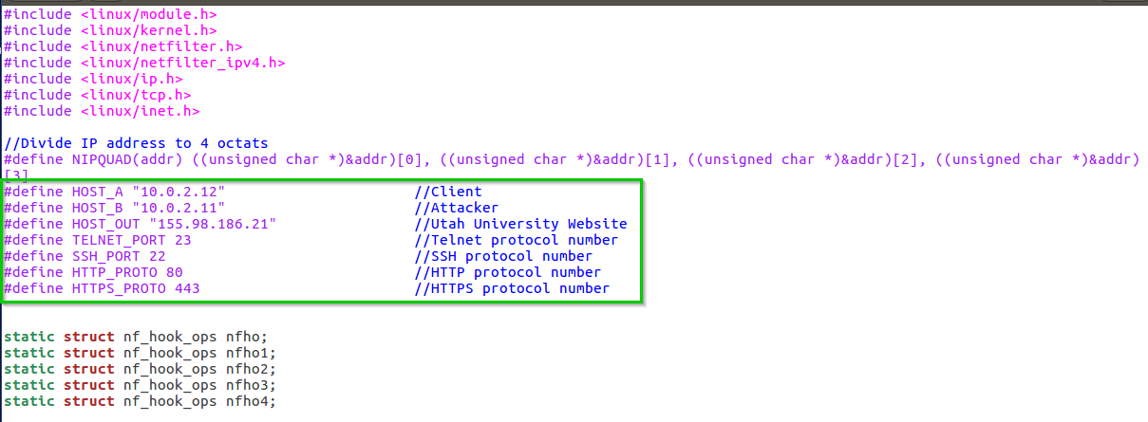

Initiate variables for our IP’s, ports.  
Note: the divide IP address define is cut in the screenshot for convenience - it does the same for ((unsinged char *)&addr)[2] and 3.

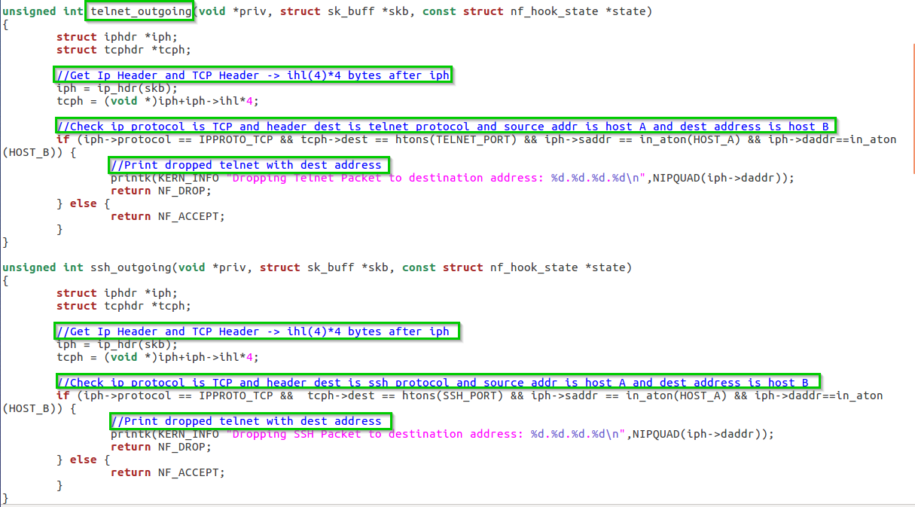The following are Telnet outgoing and SSH outgoing filtering.

We can see we initiate the ip header and tcp header from the buffer skb.

We check if the protocol is tcp, the source is A and destination B, and the port is for ssh or telnet respectively for the functions.

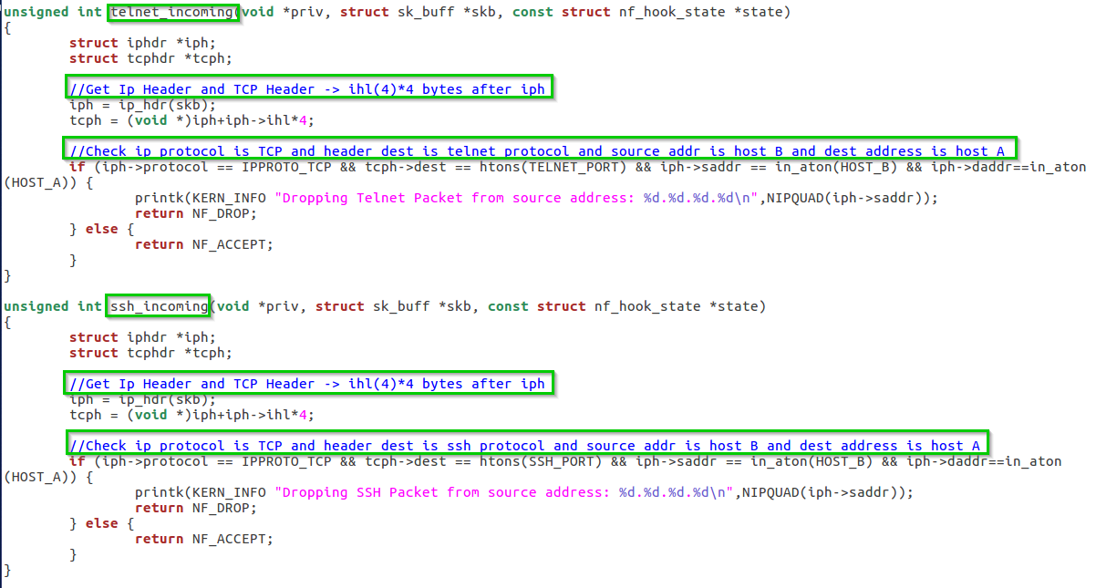The following are Telnet outgoing and SSH Incoming filtering.

We can see we initiate the ip header and tcp header from the buffer skb.

We check if the protocol is tcp, the source is B and destination A, and the port is for ssh or telnet respectively for the functions.

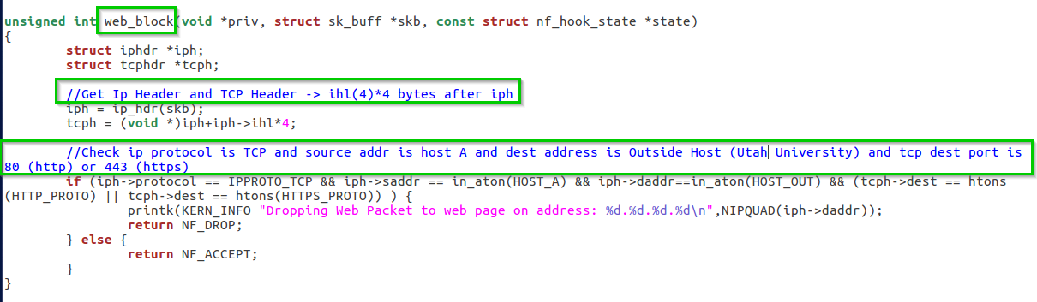The following is website filtering.

We can see we initiate the ip header and tcp header from the buffer skb.

We check if the protocol is tcp, the ports are 443 or 80 and the source is A and destination is the Utah University website IP.

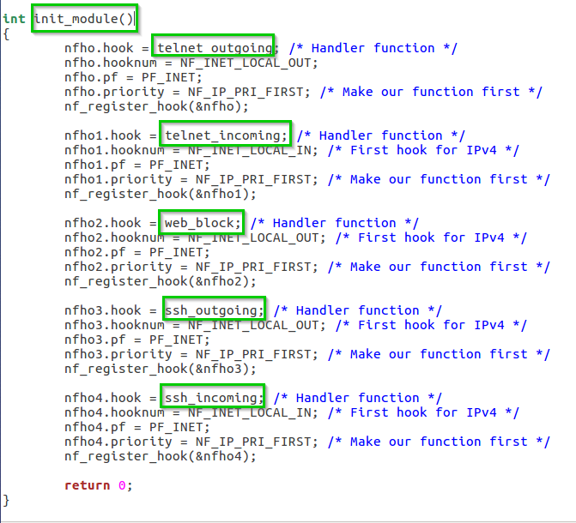Initiate of the module and our hooks.

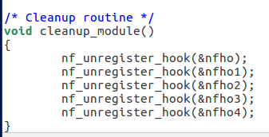Cleanup module to unregister our hooks.

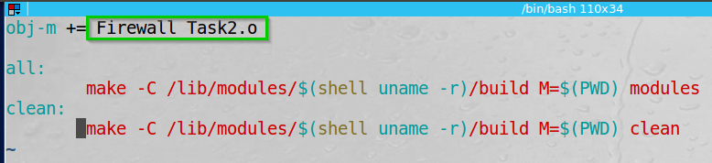On the same directory I created a file (“Makefile”) to compile make our code.

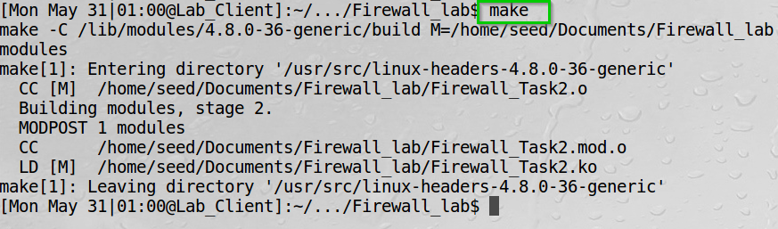Executing “make” builds our code.

We can see no errors.  
Note: when we tried it on the /home/see/host network mounted directory it did not work.

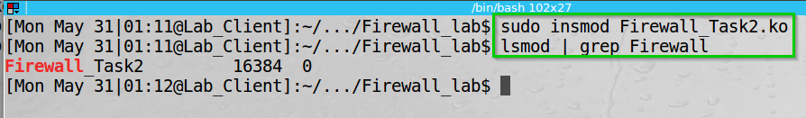Inserted the module and see it exists.

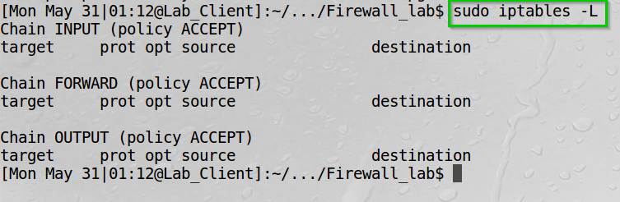Checking the iptables rules.

There are none so our modules are the one whom filtering the packets.

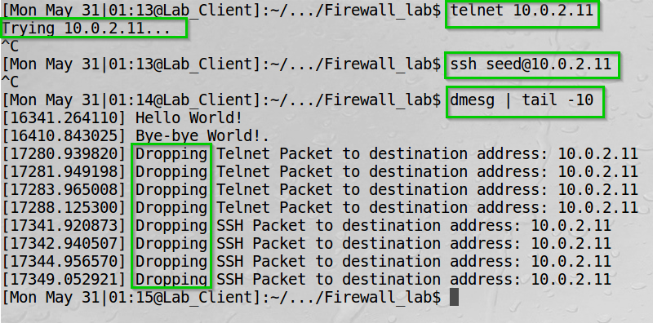Trying Telnet and SSH from 10.0.2.12 to 10.0.2.11.

We can see unsuccessful attempts and the log file showing our filtering.

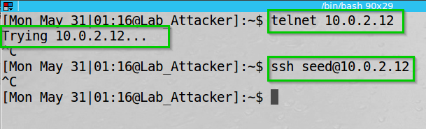Trying Telnet and SSH from 10.0.2.11 to 10.0.2.12.

We can see unsuccessful attempts.

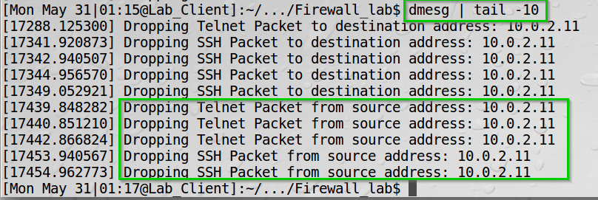Viewing the log file.

We can see the packets have dropped.

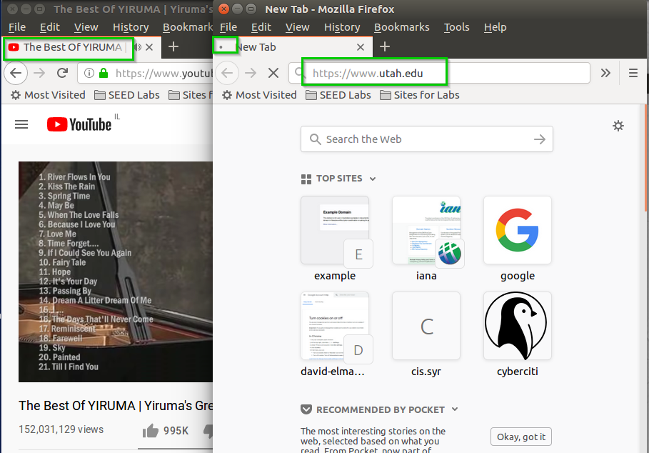Trying to browse from 10.0.2.11 to Utah University website.

We can see unsuccessful attempt.

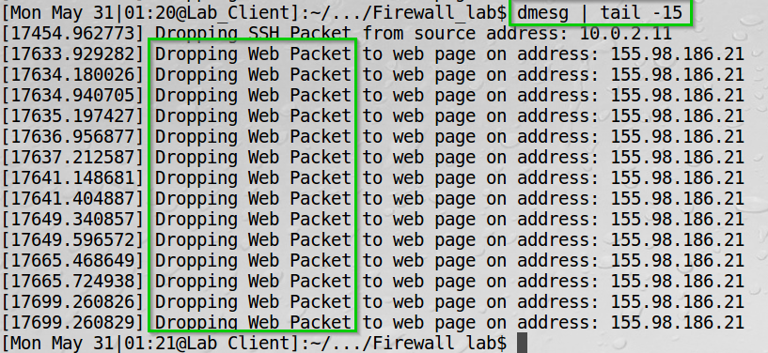Viewing the log file.

We can see the packets have dropped.

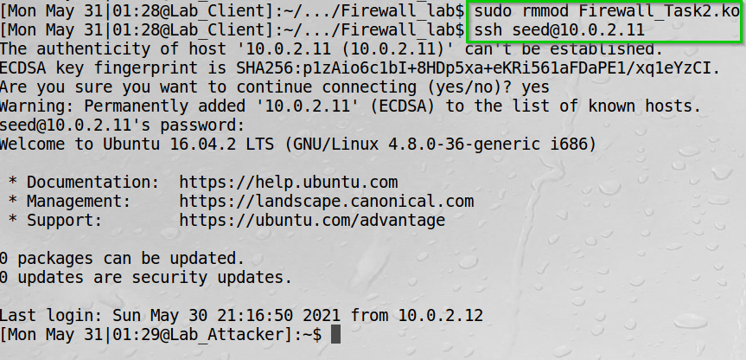Removing the module and SSH to 10.0.2.11.

We can see a successful connection.

**Task 2 Summary**

* I have learned about LKM – Loadable Kernel Modules which are modules we can insert to our kernel on the fly.
* I have learned about Netfilter – which allows us to load the LKM and call hooks on the operating system – Meaning we catch the system calls before the kernel decides what to do with it and forward it to the operating system.
* I have learned about Makefiles and how to build our code and then use these files and insert modules to the Linux kernel.
* I implemented hooks to catch SSH, Telnet and connection to Utah University website and decide what to do with it.

**Task 3: Evading Egress Filter**

**Network physical topology:**

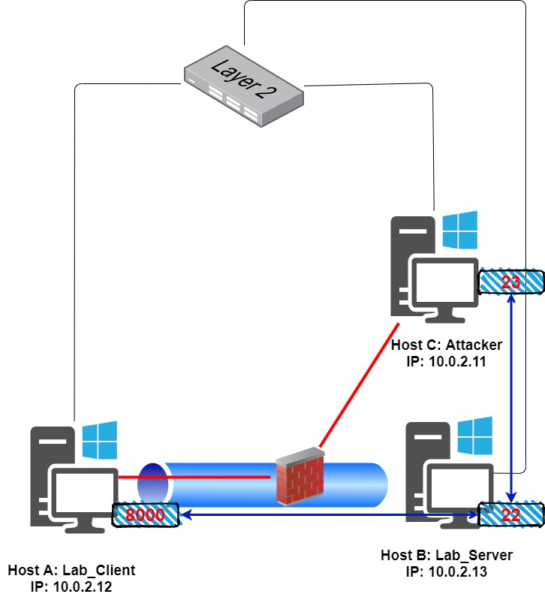

**Task Description:**

**Task 3.a** - Iptables rules will deny us from initiating telnet to a remote server.

I will evade iptables filtering by using SSH connection from one host to another through intermediate host.

**Task 3.b** - I will also block communication with Utah University website and set Firefox proxy as localhost:9000 to bypass the block (using dynamic port forwarding).

**Task 3.a:**

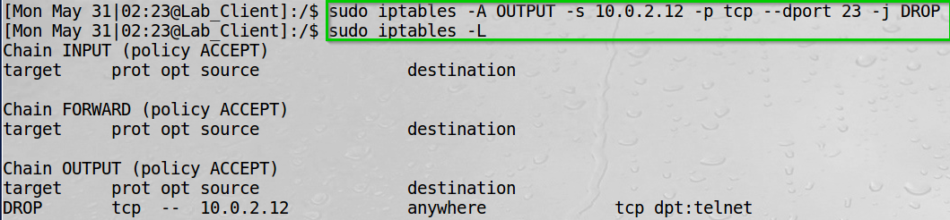The following rule filter outgoing telnet session from 10.0.2.12 to anywhere.

We can see the rule updated in the iptables.

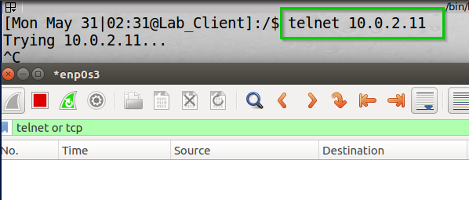I tried to initiate telnet session to 10.0.2.11.

We can see unsuccessful attempt and no packets on Wireshark.

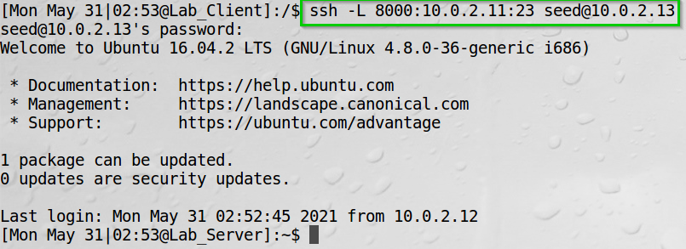I established SSH tunnel between host A and B.

We can see successful login to 10.0.2.13 using SSH.

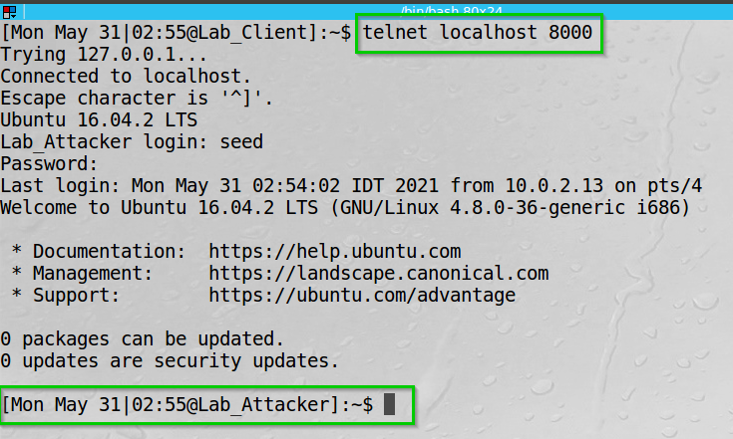Then I used the tunnel we created – telnet to localhost on port 8000.

We can see successful connection to C (10.0.2.11).

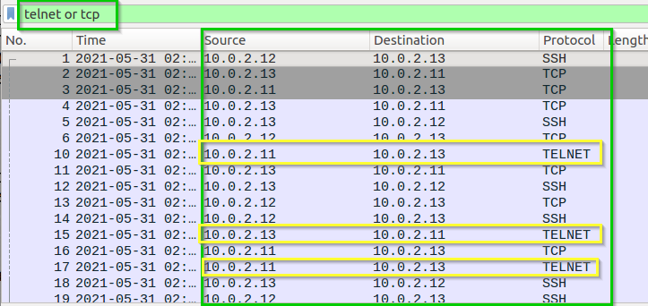Wireshark view.

We can see we (10.0.2.12) communicate with B (10.0.2.13) through SSH, and B (10.0.2.13) communicate with C (10.0.2.11) through telnet – thus creating a tunnel for us to communicate with 10.0.2.11.

**Task 3.b:**

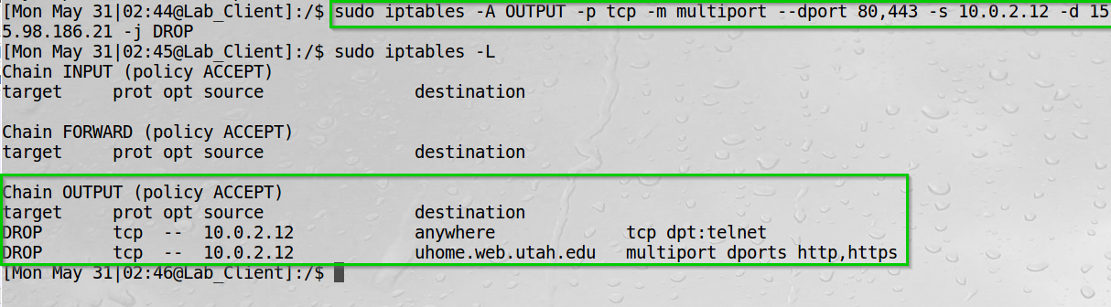The following rule block out going traffic on ports 80,443 from 10.0.2.12 to Utah University website.

We can see the rule in iptables.

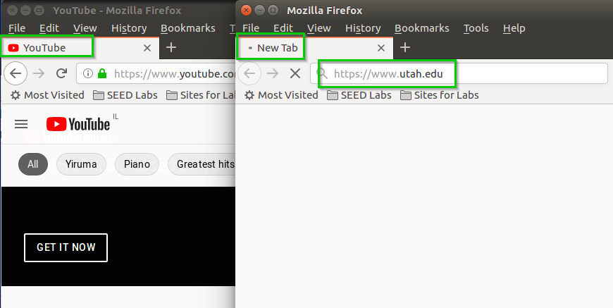I now try browsing to Utah University website.

We can see unsuccessful attempt.  
YouTube is to show network connectivity.

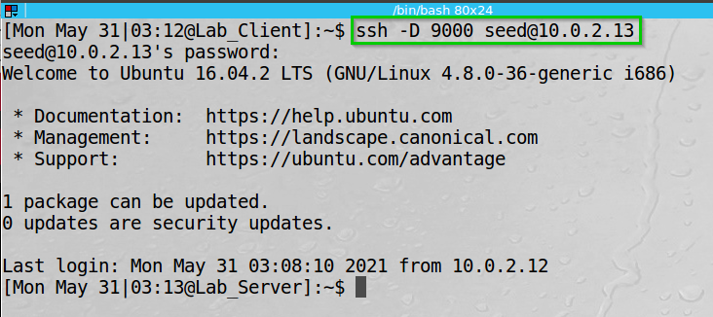  
I then SSH to 10.0.2.13 on port 9000 and later configure Firefox to use this port as the port forwarding port.

We can see successful connection.

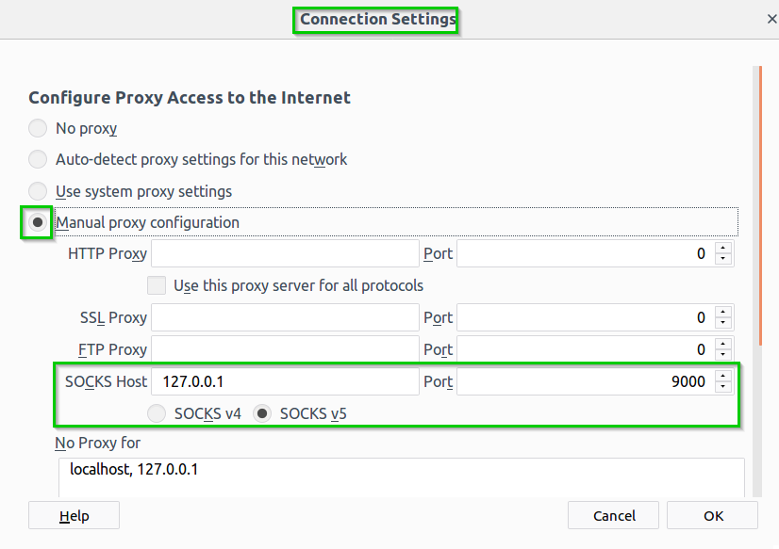I configured Firefox proxy settings.

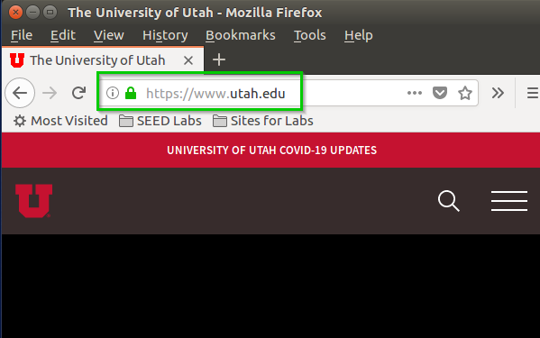Then browsed again to Utah University website.

We can see a successful connection.

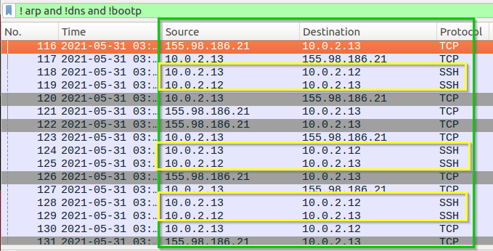Wireshark view.

We can see we communicate with 10.0.2.13 through SSH and 10.0.2.13 communicate with 155.98.186.21 for us.

I broke the connection.

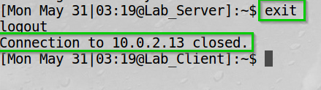

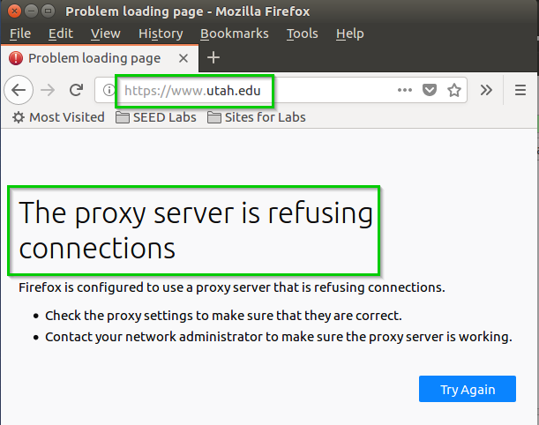Then tried browsing again.

We can see that we cannot connect to the University website.  
Firefox tries to communicate with localhost at port 9000, however it is closed.

After initiating the SSH tunnel again I can browse to the university website again.

**Task 3 summary**

* I blocked outgoing Telnet from 10.0.2.12, then executed   
  ‘ssh -L 8000:10.0.2.11:23 seed@10.0.2.13’ to create a tunnel from 10.0.2.12 to 10.0.2.11 through 10.0.2.13.
* I blocked ports 80 and 443 to Utah University website, the executed ‘ssh -D 9000 seed@10.0.2.13’ and configured Firefox proxy through port 9000  
  Then connected to 9000 port to SSH and could browse to Utah University website.

**Task 4: Evading Egress Filter**

**Network physical topology:**

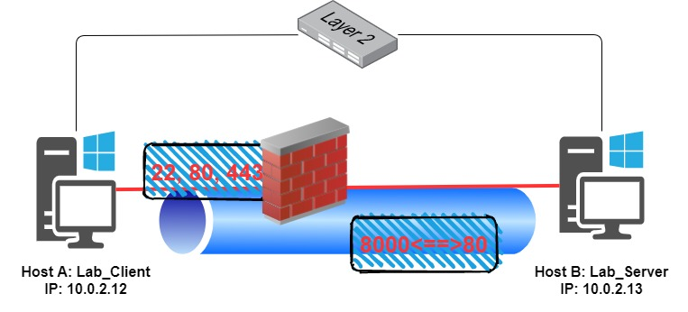

**Task Description:**

Similarly, to Task 3, I block ports 22,80,443 from A (10.0.2.12) to B (10.0.2.13), however the tunnel now would be SSH Reverse Path from B to A.

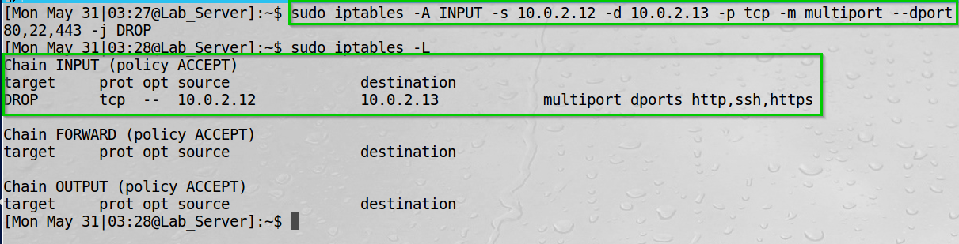The following rule filter Incoming traffic on ports 22,80,443 from 10.0.2.12 to 10.0.2.13.

We can see the filter updated in the iptables.

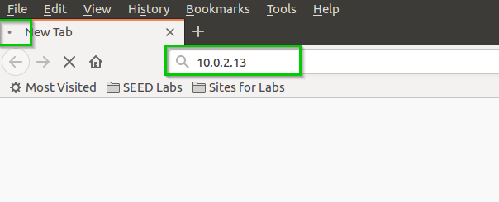I browsed to 10.0.2.13 website.

We can see unsuccessful attempt.

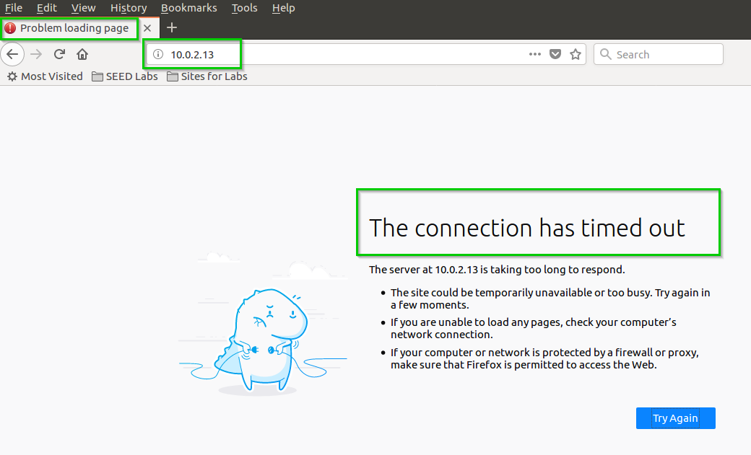We can even see the connection is timed out.

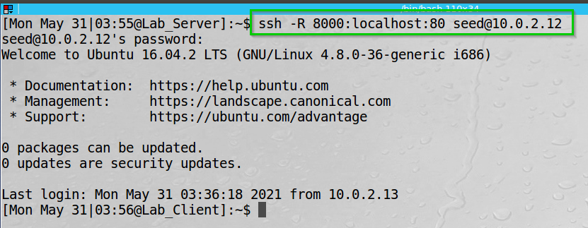I created SSH Reversed Path from 10.0.2.13 to 10.0.2.12 on port 8000 accessing localhost (10.0.2.13) on port 80.

The website is hosted under /var/www/html as index.html

I changed the content of the file.

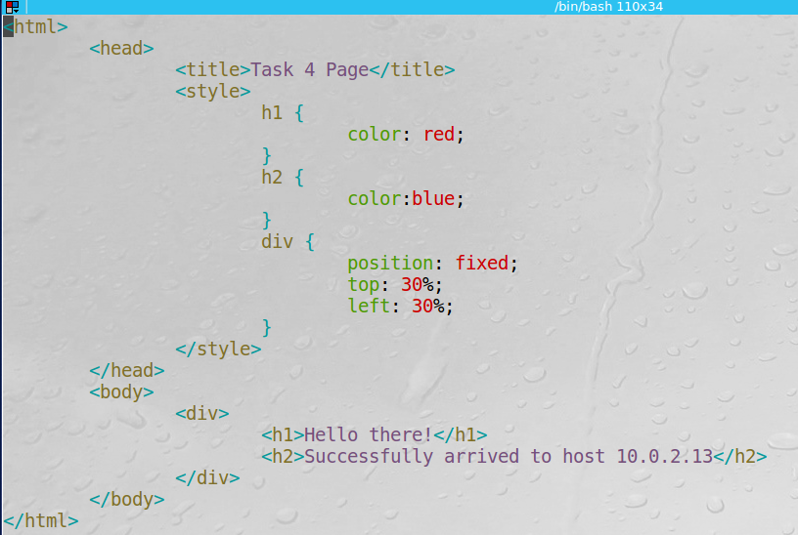

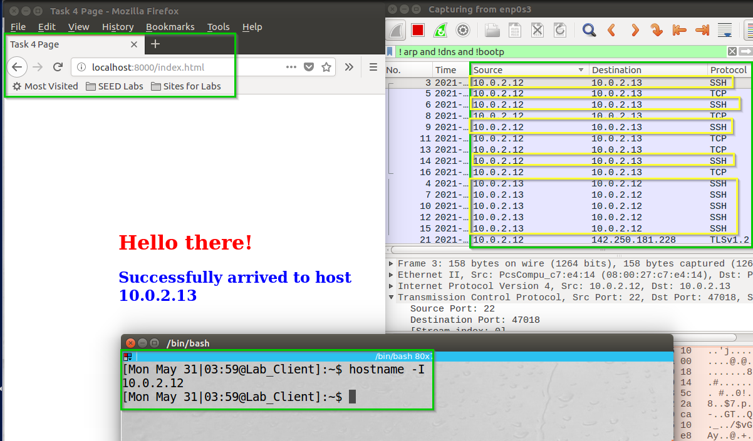Then I browsed to localhost:8000/index.html from 10.0.2.12 and got to the 10.0.2.13 website.

We can see I’m on 10.0.2.12 and got to the 10.0.2.13 website by browsing to localhost 8000.  
We can also see the behavior of our connection on Wireshark -  
only SSH between 10.0.2.12 and 10.0.2.13

**Task 4 summary**

* I blocked port 20,80,443 from A to B.   
  Then we tunneled using SSH Reverse Path from B to A:  
  ‘ssh -R 8000:localhost:80 seed@10.0.2.12’
* I edited the index.html file on 10.0.2.13 and browsed from 10.0.2.12 to 10.0.2.13:8000/index.html and was able to reach the website.

**Lab Summary**

**Task 1:** I have learned using iptables as our Firewall.

I opened Telnet and SSH connection between A and B and Utah University website. Then, applied iptables rule to block the communication.

**Task 2:** I have learned about LKM – Loadable Kernel Modules which are modules we can insert to our kernel on the fly.

I have learned about Netfilter – which allows me to load the LKM and call hooks on the operating system – Meaning we catch the system calls before the kernel decides what to do with it and forward it to the operating system.

I have learned about Makefiles and how to build my code and then use these files and insert modules to the Linux kernel.

I implemented hooks to catch SSH, Telnet and connection to Utah University website and decide what to do with it.

**Task 3:** I blocked outgoing Telnet from 10.0.2.12, then executed   
‘ssh -L 8000:10.0.2.11:23 seed@10.0.2.13’ to create a tunnel from 10.0.2.12 to 10.0.2.11 through 10.0.2.13.

I blocked ports 80 and 443 to Utah University website, the executed   
‘ssh -D 9000 seed@10.0.2.13’ and configured Firefox proxy through port 9000  
Then connected to 9000 port to SSH and could browse to Utah University website.

**Task 4:** I blocked port 20,80,443 from A to B.   
Then, tunneled using SSH Reverse Path from B to A:  
‘ssh -R 8000:localhost:80 seed@10.0.2.12’

I edited the index.html file on 10.0.2.13 and browsed from 10.0.2.12 to 10.0.2.13:8000/index.html and was able to reach the website.